ENTRY FORM

Full Name . . . . . . . . . . . . . . . . . . . . . . . . . . . . . . . . . . . .

Address . . . . . . . . . . . . . . . . . . . . . . . . . . . . . . . . . . . . . .

. . . . . . . . . . . . . . . . . . . . . . . . . . . . . . . . . . . . . . . . . . . .

. . . . . . . . . . . . . . . . . . . . . . . . . . . . . . . . . . . . . . . .. . . . .

postcode . . . . . . . . . . . . . . . . . . . . . . . . . . . . . . . . . . . . .

Home Tel. No. . . . . . . . . . . . . . . . . . . . . . . . . . . . . . . . .

Email . . . . . . . . . . . . . . . . . . . . . . . . . . . . . . . . . . .. . . . .

ECF Grade . . . . . . . . . . . . . . . . . . . . . . . . . . . . . . .. . . . .

ECF Code . . . . . . . . . . . . . . . . . . . . . . . . . . . . . . . . . . . .

Date of Birth . . . . . . . . . . . . . . . . . . . . . . . . . . . . . . . . . .

Club/School . . . . . . . . . . . . . . . . . . . . . . . . . . . . . .. . . . .

Tournament entered . . . . . . . . . . . . . . . . . . . . . . . . . . .

½ point bye in round? (not in round 5) . . . . . . . . . . . . . .

Entry fee - - - - - - - - - - - - £ . . . . . . . . . .
(£5 discount for players under 18 –
on 31/8/2011 - - - - - - - - -
Additional fees
Late fee - £3 - (for entries
postmarked after 24/3/2012)
Telephone entries - £5
Entries on the day - £5 £ . . . . . . . . . .

Donation, thank you - - - - - - £ . . . . . . . . . .
----------------

Total amount due - - - - - - - £ . . . . . . . . . .
========================================
On Sunday, £2 will be refunded to ECF Direct Members
upon production of a valid (2011/12)
ECF Direct Member/Life Member Card
========================================
Please make cheques payable to
“South Herts Chess Congress”
===============================
Please enclose a stamped, addressed envelope
if a reply is required for : (tick as appropriate)
Receipt of entry - - - /Accommodation list - - -
RULES
Times of play 5 Round Swiss Tournaments
Saturday R1. 10:00 R2. 14:30 R3. 18:30
Sunday R4. 10.00 R5. 14:30
Prize giving 18:30 approx on Sunday
--------------------------------------------------------
1 Rate of play
36 moves in 90 minutes
30 moves in 75 minutes for re-paired games
2 Unfinished games will be decided
by a 15 minute Quick Play finish
3 The controller’s decision in all matters is final
--------------------------------------------------------
GENERAL INFORMATION
The organisers reserve the right to refuse entries, transfer entries, and to revise prize money,
according to circumstances.
If your opponent has not arrived within 30 minutes of the start of a round s/he is defaulted and you should report to the Controller’s desk for re-pairing.
A ½ point bye may be requested in advance,
except in round 5.
Refunds will not be granted for non-appearance.
--------------------------------------------------------
Ungraded players Except in the OPEN
No ungraded player may win more than a maximum of £40. However, to be eligible for this prize money they must have provided written evidence of their playing strength, before Sunday 25th Match 2012.
No smoking is allowed in the school, or its grounds.
Use of mobile phones in the playing hall
will be penalised !
--------------------------------------------------------
PAYPAL entry
To pay and enter the congress using PayPal, go to
www.stalbanschessclub.org.uk and follow the instructions.
The Congress Chief Organiser is Ray Claret
(In emergencies only, phone 07802 419545)
The Controller is: Tim Thurstan (BCF Arbiter)
We look forward to seeing you at the Congress at
St. Columba’s College, King Harry Lane, St.Albans. AL3 4AW on Saturday 31st March.
This event is organised by the St. Albans Chess Club
which meets on Mondays at the
The County Constitutional Club
29 Ridgmont Road, St Albans. AL1 3AG
(from September to June)
6:30 – 7.30 pm for the Early Knights Juniors,
and from 7:30 – 11.00 pm for adults.
New members of all abilities are welcome. For further details contact Ray Claret on 07802 419545 or email – enquiries@stalbanschessclub.org.uk
www.stalbanschessclub.org.uk

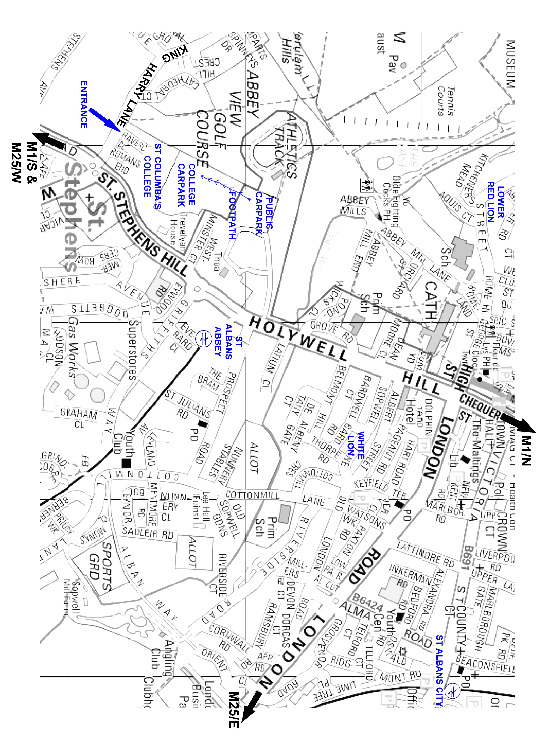

TOURNAMENTS
Open Entry Fee £30
No grade limits
Prizes £300 £150 £75
Grading Prize for players below 185 £60
Challengers Entry Fee £25 For players graded 180 and below
Prizes £250 £125 £65 + Grading Prize £25
Major Entry Fee £25
For players graded 160 and below
Prizes £250 £125 £65 + Grading Prize £25
Intermediate Entry Fee £25
For players graded 140 and below
Prizes £250 £125 £65 + Grading Prize £25
Minor Entry Fee £25
For players graded 120 and below
Prizes £250 £125 £65 + Grading Prize £25
** £5 DISCOUNT FOR PLAYERS UNDER 18 **

For best performance by a junior under 14 £40
Veterans Prize age over 65 £40
Age on 31.8.2011 determines qualification
All games will be graded under the ECF Game Fee Scheme.

We regret that wheelchair access to this venue is difficult.
St. Albans Chess Club’s Summer venue, and only 10 minutes walk from the Congress, is THE WHITE LION 91 Sopwell Lane, St. Albans. AL1 1RN
2006 CAMRA Pub of the Year – overall winner A pub with a great selection of real ales, Fine wines, home-made food, and live music. Email – David@TheWhiteLionPH.co.uk Telephone 01727 850540

GOLDERS GREEN RAPIDPLAY CHESS TOURNAMENTS
Organised Monthly by Adam Raoof
Open, U170, U145, U120
at Golders Green Parish Church Hall,
West Heath Drive (off North End Road),
London NW11 7QG
www.goldersgreenchess.tk

LOWER RED LION The 17th Century Coaching Inn at
36 Fishpool Street, St. Albans. AL3 4RX.
6 real ales, 4 ever-changing guests, real cider
Comfortable B&B at reasonable rates Lunch time meals.
Tel:- +44(0)1727 855669
email:- contact@lowerredlion.co.uk
www.lowerredlion.co.uk
30th St. Albans
South Herts
Chess Congress 2012

Saturday 31st March – Sunday 1st April

Sponsored by
Tournament Chess Supplies
at St. Columba's College King Harry Lane, St Albans AL3 4AW
With ample parking for 200+ cars CLOSE TO M1 & M25 Thameslink & Watford Junction trains Meals & refreshments available
Eligible for ECF Grand Prix 2011/12
Over £2500 in prizes
Veteran, Junior, and grading prizes
Entry Forms, fees & enquiries to: T. Douse,
c/o 23 Westfields, St. Albans, Herts. AL3 4LR
Telephone – 01727 751072
Email - shertschess@yahoo.co.uk

